**Technical Documentation – Deploy_PENFAX_PENCALC**

1. Workflow – Deploys PENFAX Artifacts to Business Servers, Online and BATCH Environments.

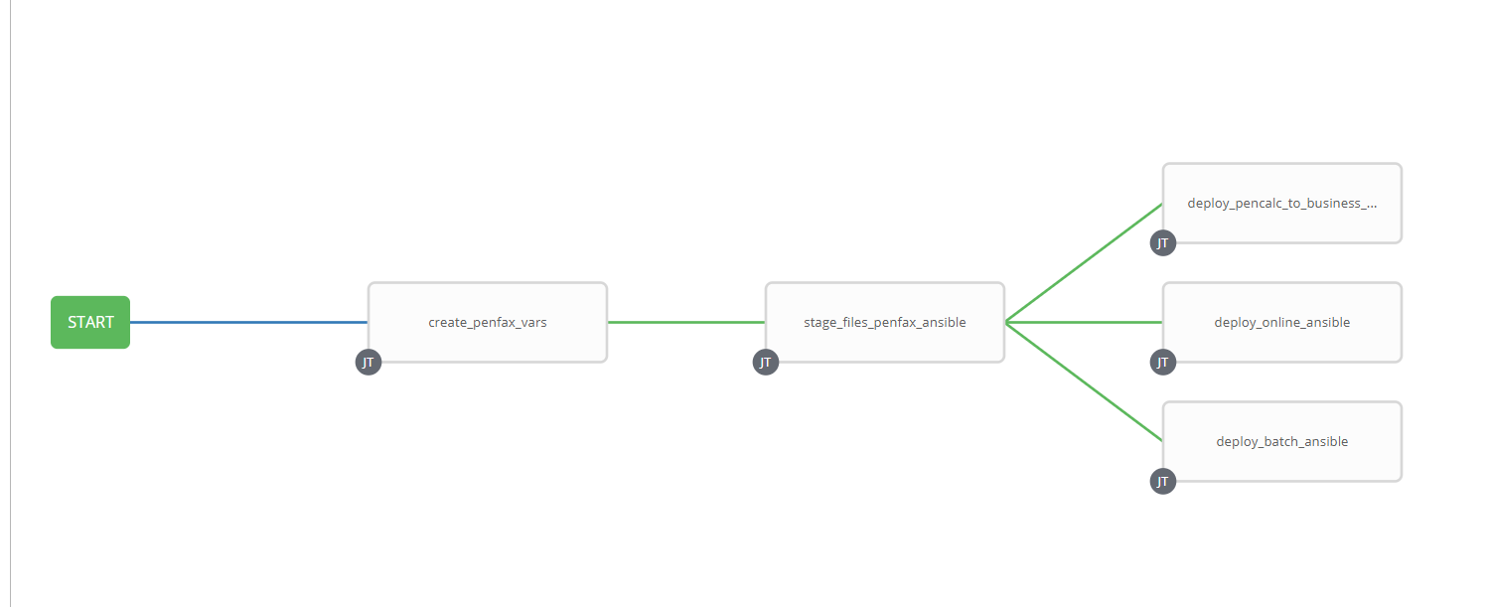

1. Survey – User Supplied Variables

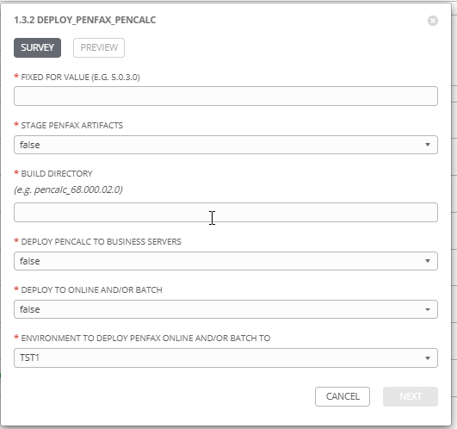

|  |  |  |  |
| --- | --- | --- | --- |
| **Survey Extra Variables** | **Prompt** | **Type** | **Description and Usage** |
| FFV | Fixed For Value | Text | The fixed for value for the deployment – must be for the format ###.###.###.### (i.e. 58.0.12.0). Numbers only with a maximum of 3 digits and there must be 4 sets separated with a ‘.’. Used to create staging and deployments directories. Used by all job templates in the workflow |
| STAGE | Stage PENFAX Artifacts | Multiple Choice Single Pick | True or false – Copies the PENFAX Artifacts from the PENFAX Build Releases Directory to the Staging folder. |
| ReleaseDir | Build Directory | Text | The /pencmw_common/PENFAX/releases/ subdirectory that contains the MSC artifacts |
| PENCALC | Deploy PENCALC to Business Servers | Multiple Choice Single Pick | false, DEV, TEST, MAINT, PROD – Select the Business Server Environment to deploy PENCALC to. Leave it false if it is NOT to be deployed |
| Online_Batch | Deploy to Online and/or Batch | Multiple Choice Single Pick | false, Both Online and Batch, Online, Batch – Select if Online, Batch or Both are to have PENFAX deployed. Leave it false if it is NOT to be deployed |
| ENV | Deploy to Which Environment | Multiple Choice Single Pick | The Environment to Deploy to: DEV3, DEVL, RDEV, TST1, TST2, TST3, TRNG, TRNM, MUAT, IPASP. Only a single environment can be deployed to per workflow execution |

1. Jobs Used by the workflow - http://owl.penc.local:18080/svn/deploy_automation/trunk/Ansible_PlayBooks/PENFAX

| **Job Template** | **Ansible Playbook** | **Credentials / host** | **Project** | **Description and Usage** |
| --- | --- | --- | --- | --- |
| create_penfax_vars | create_penfax_vars_ansible.yml | None – runs on localhost as awx linux user | PENFAX Deployments | Output from playbook.  DeploymentLogDir: /codemove_common/dp_automation/deployments/068.000/068.000.015.000/PENFAX  StageDir: /codemove_common/dp_automation/stage/068.000/068.000.015.000/PENFAX  batch_dir: /home/jcs/jcsrdev  date_time: '20200708_1438'  deployment_batch_host: diagoras1bcp – setting based on Online_Batch value and ENV value  deployment_online_host: none – setting based on Online_Batch value and ENV value  jcsOwner: jcsrdev.devel  online_compile_dir: /export_home/codemove/compile/ipas12c/rdev/penfax  online_runtime_dir: /opt/ipas_app_dev/rdev/penfax  pencalc_hosts: none – setting based on PENCALC values  stage_server: diagoras1bcp |
| stage_files_penfax_ansible | stage_files_penfax_ansible.yml | codemove on {{stage_server}} – typically diagoras1bcp | PENFAX Deployments | Copies Penfax Artifacts from /pencmw_common/PENFAX/releases/{{ReleaseDir}} to {{StageDir}}/{{ReleaseDir}}.  The job fails if /pencmw_common/PENFAX/releases/{{ReleaseDir build directory does not exist.  If the stage_server is set to ‘none’ as opposed to diagoras1bcp, the playbook skips all tasks.  The last task of the job creates a Staging Report in the {{DeploymentLogDir}} in html format. |
| deploy_pencalc_to_business_servers_ansible | deploy_pencalc_ansible.yml | codemove on {{stage_server}} – typically diagoras1bcp | PENFAX Deployments | Stops pencalcd on the business servers  Takes a backup of the current pencalc directory – NOTE THIS ALWAYS PRODUCES AN ERROR BUT IT IS SUCCESFUL – The task backs up the pencalc directory to a subdirectory within itself (historically this is the process). This means it is trying to backup these ‘backup subdirectories’ which produces an error since it is not a recursive copy – this is expected.  It then deploys the new artifacts and starts pencalcd  The job then populates the deployment log for the host.  Note: if the pencalc_hosts is set to ‘none’ all tasks are skipped |
| deploy_online_ansible | deploy_online_ansible.yml | codemove on {{deployment_online_host}} typically daulis1bcp | PENFAX Deployments | Copies penfax artifacts to the online compile and runtime directories alone with the sda_master config files.  The job then populates the deployment log for the Environment.  Note: if the deployment_online_host is set to ‘none’ all tasks are skipped.  Additionally the job does NOT backup the current penfax artifacts (another historical feature) |
| deploy_batch_ansible |  | codemove on {{deployment_batch_host}} typically tychon1bcp | PENFAX Deployments | Creates a backup of the current ipas.tools directory (penfax artificats)  Deploys the new penfax artifacts to the ipas.tools directory, along with the sda_master config files  Changes the rwx privs based on the type of environments (i.e. every environment other than IPASP gets ‘chmod 755’. IPASP environment gets ‘chmod 775’.  The job then populates the deployment log for the Environment.  Note: if the deployment_batch_host is set to ‘none’ all tasks are skipped |